Title of your abstract
First author name^{1,*}, Presenting Author¹, Third Author², Fourth Author^{2,3}, Senior Author¹
- Department, Institution, Address, Country
- Company name, Address, Country
- Research institute, Institution, Address, Country
- Corresponding author, email@institution.com
Keywords keyword1, keyword2 … (write 3 – 5 keywords)
Abstract
The abstract should include key elements, but the body's exact structure is not specified.
Key elements of abstract
- Background - briefly state the problem and its significance
- Objective - clearly define your research aim
- Methodology - concisely describe your approach, techniques, and key technologies used
- Main results - present key findings with quantitative data and performance metrics
- Conclusion - summarize the impact and potential applications of your work
Subtitles – use the style: AE-Subtitles2 for structuring your abstract.
References
- PETIT, C. and SIEFFERMANN, J.M. Testing consumer preferences for iced-coffee: Does the drinking environment have any influence? [online]. 1 January 2007. Vol. 18, no. 1, pp. 161-172. DOI 10.1016/j.foodqual.2006.05.008.
- ANGELOU, Maya. I Know Why the Caged Bird Sings. 1. New York: Random House, 1969. ISBN 9780375507892.

Notes:
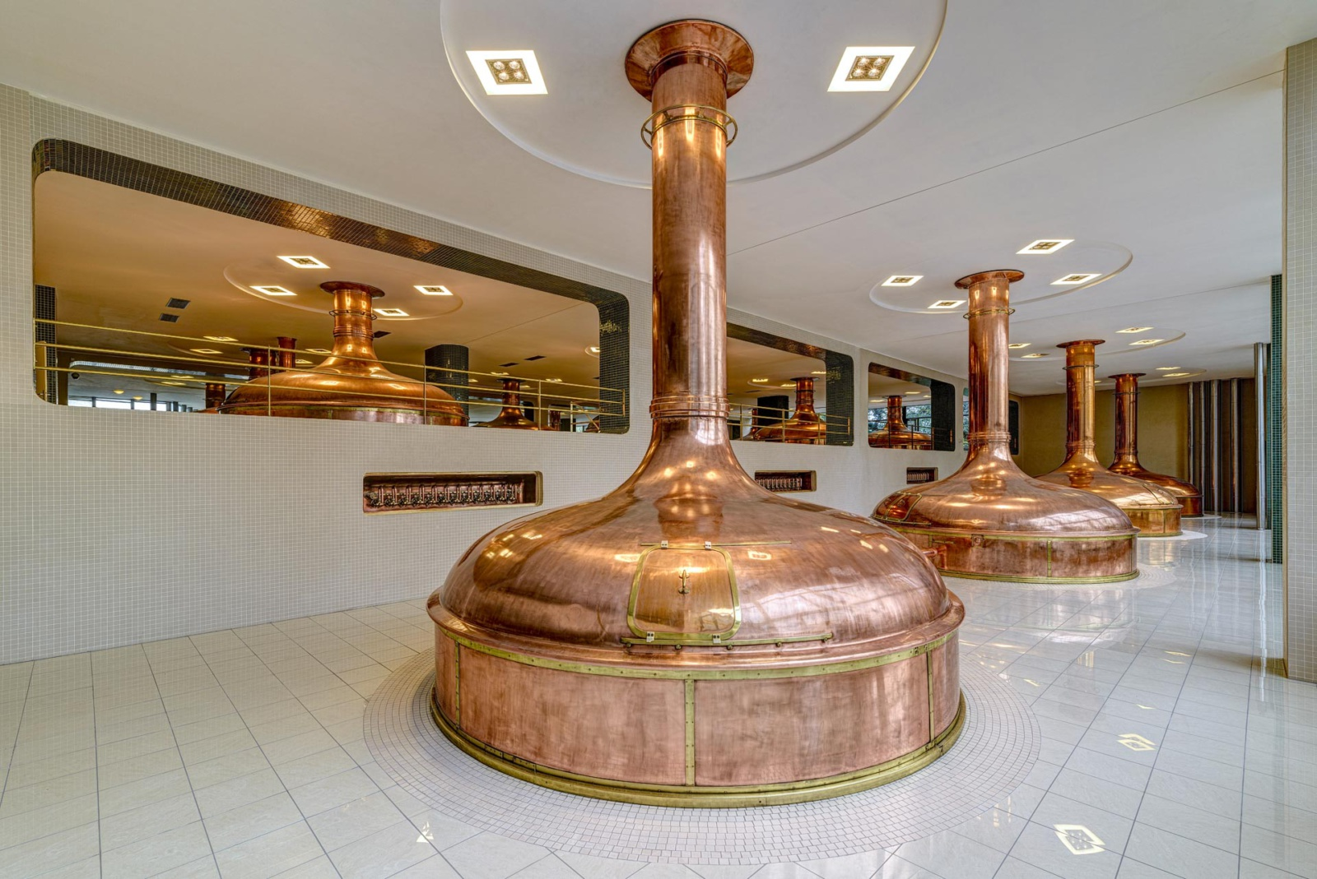
Figure 1. Pilsen - Built on Steel, Perfected in Beer

This is a template for the abstract submission to the 31st International Conference on Applied Electronics (AE2026), to be held 7 – 9 September 2026 in the beautiful city of Pilsen, Czech Republic (Figure 1).
The abstract needs to be uploaded to the website https://appel.zcu.cz
Please indicate also your preferences:
- presentation type (“oral presentation” or “poster presentation with 2-minute pitch)
- contribution type (“only abstract” or “abstract + full paper in conference proceedings”
Please stick to the template's layout for submitting the abstracts. Please note that the presenting author must be underlined. The text is formatted in Times New Roman, font size 12. Figures are included in floating boxes, which can be duplicated where necessary. Please limit your abstract to 1 or 2 pages, depending on the number of figures. For uniformity, we do not have a LaTeX template available. Please do not forget to convert your abstract into a .pdf file! For further questions, please get in touch with us at appel@fel.zcu.cz.

